TLM Electrometer 10/10/12 Meeting Minutes
Attendees: Jim Zagel, Peter Prieto, Dan Schoo, Marv Olson, Dave Peterson, Paul Czarapata, & Tony Leveling
Purpose: To clarify the Instrumentation Department scope of work and specifications for a TLM electrometer
Prepared by: T. Leveling, 10 15/12

Discussion
Jim Zagel requested this meeting after the Instrumentation Department reviewed materials from TLM References on the TLM Works Page (http://www-muon.fnal.gov/Personnel/Leveling/TLMs.htm). The TLM Works Page is a collection point for all work related to developing the TLM system and no clear cut lines have been drawn yet to define the Instrumentation Department role in bringing the TLM system to life. In this meeting, the Instrumentation Department asked questions which make it clear that it is now necessary to define more clear lines of responsibility as we develop the TLM system.

Delineation of Project Responsibilities
There was a lengthy discussion on design elements for the TLM system. There are 5 entities responsible for the development of the TLM system design. The entities and their specific responsibilities are outlined here:
- ES&H Section: The ES&H Section has responsibility for the final review and approval of the complete TLM system.
- AD ES&H Department: The AD ES&H Department is responsible for submitting the TLM system design and implementation plan to the ES&H Section for its review and approval. As such, the AD ES&H Department plays an important role in ensuring that the design of the system will meet all Radiation Safety System Interlock requirements. The AD ES&H Department will also eventually be responsible for acceptance testing, calibration, maintenance, deployment, and developing the Radiation Safety System interface with the TLM electrometer.
- Instrumentation Department: The Instrumentation Department is responsible for designing and building a prototype electrometer. The basic operating principal is to be based upon the Chipmunk, a proven Radiation Safety System input device. Key features of the electrometer are:
  - The basic function of the TLM electrometer is to collect charge from a TLM ion chamber which is delivered via an RG58 cable terminated with BNC connector.
  - The input charge is to be converted to an output of TTL pulses. The manner of making this conversion is to be developed by the Instrumentation Department.
  - The value of charge represented by the TTL pulse is to be 1 nC.
  - The electrometer should be capable of collecting charge at a rate of at least 5 uC/minute.
  - Due to limitations of various systems which receive the electrometer TTL pulse output, the pulse train must be delivered with a characteristic time constant of about 20 seconds.
  - Since voltage variations cause variations in charge produced in a TLM ion chamber, a very stable HV supply is required. The electrometer must provide a 500 +/- 0.05% VDC bias voltage at an SHV connector located on the electrometer. The bias voltage is delivered to the TLM ion chamber by RG59 cable terminated on both ends with an SHV connector.
  - The cable connecting chipmunks to the RSS is a multi-conductor cable connected at the chipmunk end with a Burndy connector. The cable carries the TTL output pulse train, a DC “electrometer OK” level, and a characteristic DC ID level to the RSS. For now, it is envisioned that the RSS connection to the TLM electrometer should be functionally equivalent.
  - Critical functions of the electrometer must be monitored, for example, by a PLC. If, for example, the HV supply goes out of tolerance, the DC “electrometer OK” signal provided by the PLC, would be interrupted. Inputs to the PLC “electrometer OK” output signal would be analogous to the chipmunk “fail safe” circuitry checks.
  - A second TTL pulse train output will be provided at the electrometer at a panel mounted BNC connector. An RG58 cable will carry this second TTL pulse train to the MUX system.
  - The chipmunk TTL pulse train is provided from a common driver to both the burndy connector on the chipmunk and to two BNC connectors. The ES&H Section considers the MUX system to be a safety recording system and has not seen fit to provide separate drivers to isolate the signal destinations of the RSS and the MUX system. A few thousand unit-years of operating experience have accrued since 1995 with no known instances of unsafe operation. In spite of this, it is the opinion of a broad community of safety engineering experts that for systems such as the TLM electrometer, the TTL pulse signal needs to be provided to each output by a separate driver so that the RSS is isolated from the BNC outputs; the purpose is to prevent a system such as the MUX system from adversely affecting the input signal to the RSS. The ACNET system monitors the MUX system from a repeater provided by the ES&H Section such that it is not possible for ACNET to change or otherwise impact the MUX system. It is important that the electrometer TTL output be recorded in a data logger system so that the radiological implications of machine operation available for review. If the data logging of safety related machine performance is interrupted, it would be prudent to also interrupt machine operation.
- Project Manager: Project Manager has two distinct responsibilities with overlapping features:
    - 1. As L3 manager for Radiation Protection for the mu2e experiment, responsible to develop a radiation protection scheme for delivery of an 8 kW proton beam to the pbar source to be used at the mu2e experiment on the muon campus. This scope of work includes development of the TLM ion chamber, ancillary systems, and protection schemes, but does not include TLM electrometer development.
    - As member of Muon Department, development of the TLM electrometer and TLM applications for other accelerator protection schemes, e.g., the Booster, MI8 Line, MI/RR, NoVA, and LBNE.
Project Manager activities for TLM system design includes:
- Characterize TLM response to known beam loss at 8 GeV at various locations in the Accumulator/Debuncher Rings
- Correlate TLM response to chipmunk response outside of thick radiation shields including the AP30 Service Building and Accumulator/Debuncher berm at the arcs
- Expand relationships in a&b to other energies and shielding thickness
- Expand relationships in a&b to include protection of labyrinths and penetrations
- Ensure the TLM system is capable to provide protection from radiation skyshine at pbar rings facility
- Develop overall TLM system design to fit within existing systems, e.g., RSS, MUX, and ACNET
- Develop electrometer requirements, using the chipmunk design elements as a template
- Develop design criteria including dynamic range requirements, output signal definition, heartbeat signal
- Develop protection scheme applications, e.g., radiation skyshine, radiation shielding, surface and groundwater protection, labyrinth and penetration, and the limitation of residual radiation dose within accelerator and beam line enclosures ( 1 watt/meter)
- Develop TLM ion chamber mechanical/electrical construction features, gas selection, and operating voltage selection
- Develop ancillary systems such as gas flow monitoring
- Record test data and design documentation
- Organize, hold, and document periodic meetings
Project Manager is also responsible to ensure that principles of the Fermilab Engineering Manual are applied to this effort.
- Division Management: Division Management provides resources, guidance, and oversight on all phases of the Accelerator Division effort for the TLM system development.

Meeting Discussion Topic
There was a discussion on the interrelationship of the various systems related to this project. A more complete block diagram showing the scope of the various systems is included below in FIGURE 1. Capabilities for the various systems, especially in terms of system performance monitoring are included in the section.
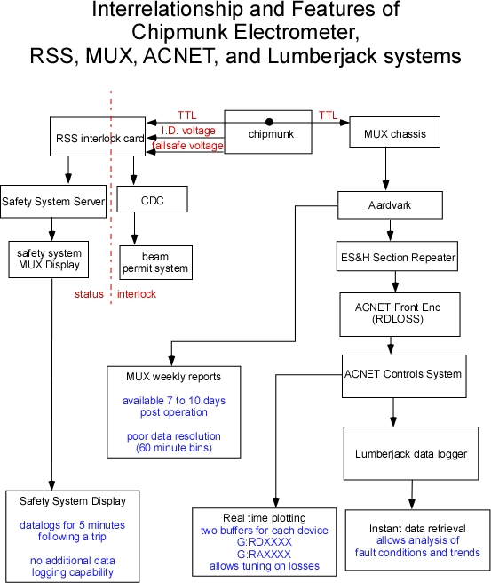
FIGURE 1

An important aspect of radiation protection systems is that their performance can be monitored. There are several monitoring functions distributed among the various systems. They are:
- The MUX system records for perpetuity the outputs from all devices connected to the system. MUX system reports are available from the ES&H Section in the form of a weekly report. Data recorded by the system in 60 minute bins and may not be available for review until 7 to 10 days post operation. An example of one page of many for the week beginning September 5, 2011 is shown in Figure 2. The 8 columns at right show the average radiation dose rate for one hour periods listed at the top of the page.
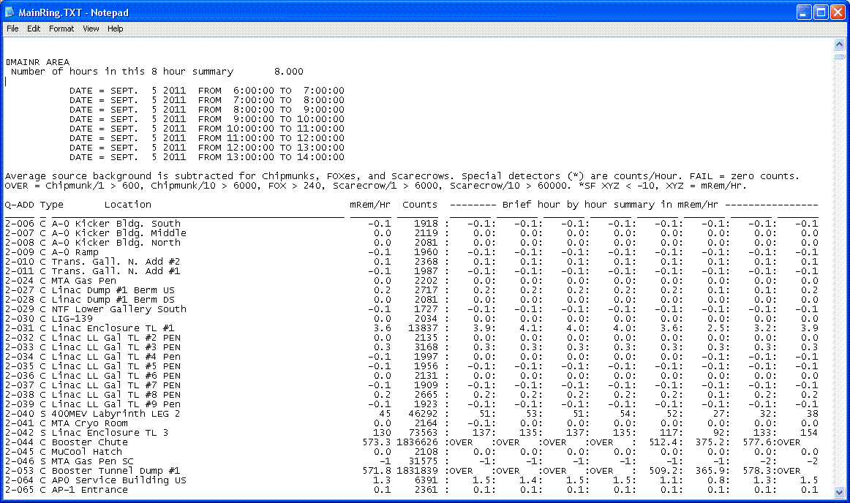
FIGURE 2: Example of report format available from the ES&H Section MUX system. The report is available 7 to 10 days after the period of operation in question. The minimum bit resolution is 1 hour. Formatting data from this report format requires a fair amount of effort.
- The Safety System Server monitors the status of the RSS. In the event of an RSS trip, the server logs the event. For devices connected to MUX, the server also records the value of the 1 minute buffer at the time of the trip and the subsequent 4 values. This data is useful for constructing the magnitude of the radiation event that caused the RSS trip. No additional data logging is available from the Safety System Server.
- ACNET monitors the MUX trunk through the RDLOSS front end developed by AD in 1996. Through ACNET, real time plotting of all devices connected to the MUX system is possible. There are two buffers in RDLOSS. One is the integrator which monitors the collection of output pulses over a period of 60 seconds. The other buffer retains the 60 second integral of pulses collected in the preceding cycle. Both devices can be plotted and appear as shown in FIGURE 3.
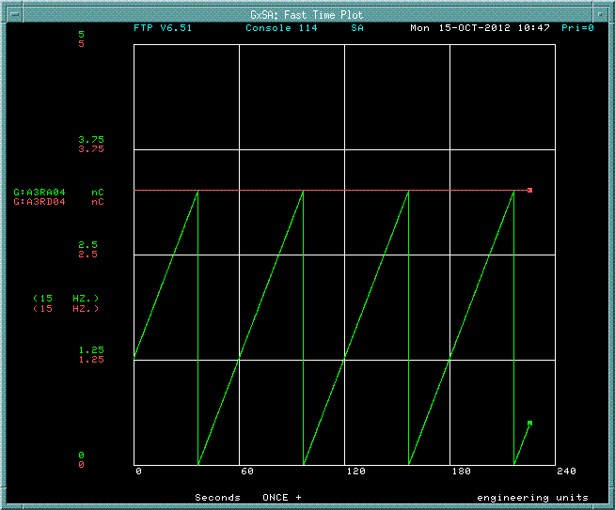
FIGURE 3: Example of Fast Time Plot Chipmunk output through ACNET plotting utility. Green trace shows real time buffer integration of collected pulsed train from G:RAXXX device over fixed 60 second intervals. Red trace shows peak value of integration buffer over previous 60 second interval for the G:RDXXXX device.

- The Lumberjack Data Logger utility records the value of G:RDXXX every 60 seconds. Figure 4 shows an example of how one may analyze output of a MUX system device connected to ACNET and data logged in Lumberjack.
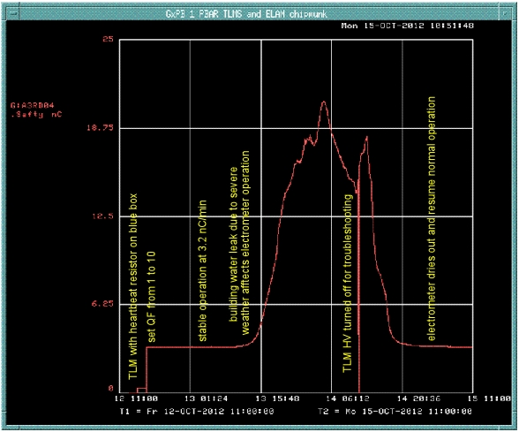
FIGURE 4: Lumberjack data logger plot of G:RDXXXX device for a 72 hour period ending 10/15/12. 4,195 data points representing 60 second integrals of chipmunk output are displayed.

Next steps
The instrumentation Department will attempt to clarify in writing its understanding of a specification for the TLM.
The Project Manager would make a similar effort (presented above) to make a specification for the TLM electrometer.
The Project Manager would make a more complete description of the interrelationship of the TLM electrometer among the various other systems discussed in the meeting. The results for this work are included above.

